Lancashire Enterprise Partnership Limited

Private and Confidential: No

Date: Wednesday, 20 December 2023

LEP input to Lancashire Devolution Consultation Exercise
(Appendices 'A' and 'B' refer)

Report Author: Andy Walker, Tel: 01772 535629,
andy.walker@lancashire.gov.uk

Executive Summary

On the 26th November 2023 the Leaders of Lancashire's upper tier local authorities signed an devolution deal with the Levelling Up Minister Jacob Young to progress devolution proposals for the area and move a step towards establishing a Combined County Authority by the Autumn of 2024.

The full council meetings at all three authorities in November unanimously agreed to the draft proposal and agreed to start a consultation period running from the 1st December 2023 to the 26th January 2024. The views of residents and key stakeholders are now invited to ensure everyone can have their say on the devolution proposals.

This report welcomes the boards views on the proposals.

Recommendation
- That members of the LEP Board individually complete the devolution consultation questionnaire and advocate for others in the business community to do so too.

- That the interim Chief Executive completes a devolution consultation questionnaire on behalf of this body based on the views expressed in the discussion of this agenda item.

Background and Advice

Attached to this report at Appendix 'A' is the authorised PowerPoint providing the background, process, timeline and high-level content / subject matter covered with Lancashire's Devolution Deal.

As the core functions of the LEP are integrated into the shadow CCA and ultimately CCA arrangements, the LEP Board are asked for their views and comments on the main policy domains of the deal.
The key features of the devolution proposal listed in the document are : -
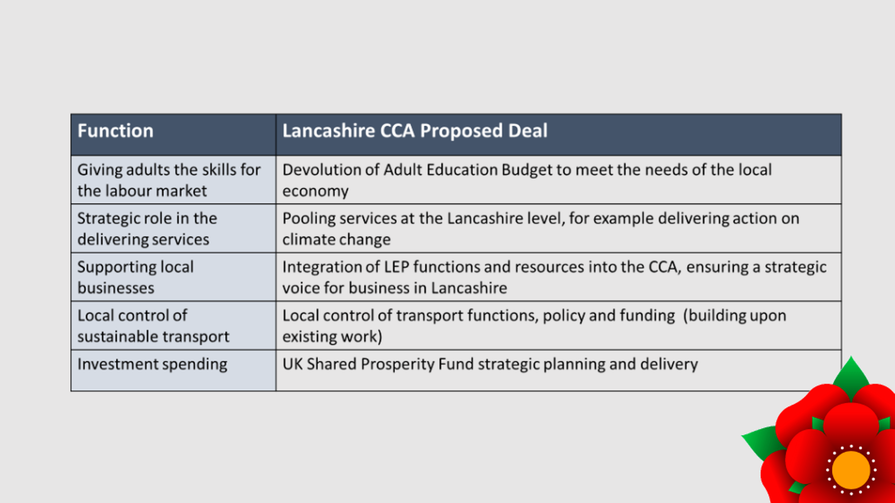

More specifically, the proposal documents references the following policy areas where the LEP has previously been active and a clear business view on issues is requested.

We propose to use devolution to build upon Lancashire’s substantial strengths in delivering benefits for its residents. This initial Proposal, if approved by the Secretary of State, will focus on the following priorities and will also establish our case for enhanced future deals.

Innovation, Trade, and Investment

We will work with local and national stakeholders to become a globally recognised and sustainable economy, distinguished by its quality of life, connectivity, and access to opportunities.

Skills

We will work collaboratively with employers, skills and training providers, local authorities and other stakeholders to support people to develop their skills throughout their lives and attract business to Lancashire because of our highly skilled workforce.

Transport

We will work with transport providers inside and outside Lancashire to create better connected infrastructure that links opportunity to need and delivers travel choices that are safe, inclusive, affordable and low carbon.

Net Zero and Climate Change

We will work across Lancashire to meet our low carbon ambitions, promote clean energy, and enhance our natural environment. Our ambition is that Lancashire becomes internationally recognised as a leader in the creation of ‘green jobs’, building upon our world class engineering and manufacturing capabilities.

Digital and Cyber

We will work across Lancashire to continue to transform our digital infrastructure and knowledge-based sectors to balance and modernise our industrial base.

Culture and Tourism

We recognise the fundamental importance of our culture and tourism assets and will work with stakeholders across Lancashire to strengthen these. This work includes the creation of a Local Visitor Economy Partnership to help further develop the region’s visitor economy.

Housing and Land

We will support the delivery of decent, affordable and low carbon housing for every community. High quality housing will benefit existing residents, as well as attract and retain the people required to drive the economy over the long term.

Format of Questionnaire Response

The questionnaire allows you to distinguish between individual and or organisational responses.

The questionnaire then goes on to ask about the extent of agreement with priorities, projects and funding allocations round the key themes listed next.
Finally there is free text box for additional comments and an opportunity to share other consultation activity as part on the consultation return for Lancashire.

LEP Board members are asked to share their views on the following seven policy domains.

1. Innovation, Trade and Investment
We will work with local and national stakeholders to become a globally recognised and sustainable economy, distinguished by its quality of life, connectivity and access to opportunities.
We will use the devolution process to refresh our strategic plans for economic prosperity. These plans will build upon our competitive advantages, exploit opportunities and develop new sectors capable of delivering long-term economic growth and creating high-value jobs. We believe the proposed CCA would enable Lancashire to produce better strategic cases for investment and gain a greater share of national resources.
The proposed CCA will plan and deliver the Lancashire area allocation of the UK Shared Prosperity Fund (UKSPF) from 2025/26. In spending this flexible funding pot, the proposed CCA will work closely with district council Leaders in an advisory capacity.
Devolution under the Proposal will provide £6 million capital investment to create an innovation hub of international excellence at Samlesbury Enterprise Zone. We believe the new centre will help stimulate the growth of new economic clusters to maximise the county-wide benefits of the £5 billion investment in National Cyber Force to be located in Lancashire.
The Proposal will also provide £6 million for the Blackburn Technology Innovation Quarter to create new business space to support the growth of Lancashire's digital, creative and cyber sectors.
Through the Proposal, Government departments will consider the potential for future relocations of Government roles to Lancashire as part of the Levelling Up agenda.
To support the proposed Lancashire CCA in its initial stages of devolution, the Government will provide £1 million of capacity funding.

2. Skills
We will work collaboratively with employers, skills and training providers, local authorities and other stakeholders to support people to develop their skills throughout their lives and attract business to Lancashire because of our highly skilled workforce.
In Lancashire's labour market, the estimated employment rate is below the national rate and has worsened since the pandemic. Lancashire's work force is also characterised by a lower proportion of residents with higher level qualifications.
The Proposal includes new powers to better shape local skills provisions to ensure these meet the needs of the local economy. This will include devolution of adult education, the core Adult Education Budget, and the opportunity to further refine the Local Skills Improvement Plan. Funding for Free Courses for Jobs will also be devolved and will be ring-fenced.
A strong, resilient and inclusive economy brings health benefits to its residents. As a combined authority, we believe Lancashire will be better placed to bid to become a pilot on national programmes that support individuals with health conditions to remain in the workplace.

3. Transport
We will work with transport providers inside and outside Lancashire to create better connected infrastructure that links opportunity to need and delivers travel choices that are safe, inclusive, affordable and low carbon.
The Proposal will build on a successful track record of major transport investment, and a new Local Transport Plan will set the direction and priorities for highways and transport investment. This plan will work across the county to secure the benefits of connectivity to widen transport choices and support low carbon travel opportunities. Lancashire has significant plans for road, bus and rail schemes, and active travel projects that it is seeking to fund through devolution.
The Proposal includes new powers to improve and better integrate local transport, including the ability to develop the bus service improvement plan (BSIP) partnership and strengthen coordination of local transport functions.
Blackpool Transport Services (BTS) will continue to operate tram services in Blackpool and the surrounding area and Blackpool Council will retain the relevant powers to manage BTS. Maintenance of tram infrastructure and assets will continue to be the responsibility of Blackpool Council in partnership with Lancashire County Council. BTS also provides vital bus services to Blackpool and the surrounding area. BTS will continue to deliver bus services locally.
The Proposal includes plans to improve public electric vehicle charging infrastructure to increase the uptake of electric vehicles and reduce carbon emissions.
As set out in a recent Network North announcement:

- The proposed CCA will receive a proportion of the £2.5 billion announced as part of Network North to transform local transport in areas in the North outside of the big city regions.
- The proposed CCA will receive a proportion of the £770 million of funding for Bus Service Improvement Plans in the North.
- The proposed CCA will receive a proportion of the £3.3 billion funding to fix potholes in the North.

We believe devolution will support Lancashire's objective of maintaining a safe and reliable transport network.

4. Net Zero and Climate Change
We will work across Lancashire to meet our low carbon ambitions, promote clean energy, and enhance our natural environment. Our ambition is that Lancashire becomes internationally recognised as a leader in the creation of 'green jobs', building upon our world class engineering and manufacturing capabilities.
Lancashire's energy and low carbon sector is particularly important due to its capabilities in designing and manufacturing low carbon technologies. The area is forecast to have the highest number of jobs per capita in the energy and low carbon sector in England between 2030 and 2050. Through the Proposal, if adopted, the Government will work with the proposed CCA to enable the continued growth of this sector by supporting the delivery of Lancashire's energy and low carbon sector plans.
Devolution would provide £2 million additional investment to extend eligibility criteria for the 'Cosy Homes in Lancashire' domestic retrofit scheme. We believe this investment will support a reduction in carbon emissions, better quality housing and improved health outcomes.

5. Digital and Cyber
We will work across Lancashire to continue to transform our digital infrastructure and knowledge-based sectors to balance and modernise our industrial base.
Lancashire has continued the development of the Lancashire Infrastructure Plan and supported rollout of Openreach and gigabit programmes, including establishing Superfast Atlantic connection with the North Atlantic Loop at Blackpool Enterprise Zone. This increased digital connectivity provides competitive advantages to attract more cutting-edge, technology-based industries.
Locating the National Cyber Force in Lancashire will attract significant investment and create over 2,000 new jobs. The proposed Lancashire CCA will work with the Department for Science, Innovation and Technology, to fully capture the investment, business, research and skills benefits of this new location. These activities will create opportunities and new careers for residents, develop markets and technologies of local businesses and help to establish a North West Cyber Corridor.
Devolution under the Proposal would provide £6 million investment for a Low Carbon Data Demonstrator Centre at Blackpool Enterprise Zone. The project will provide new business space to support Lancashire's low carbon and digital innovation ambitions.

6. Culture and Tourism
We recognise the fundamental importance of our culture and tourism assets and will work with stakeholders across Lancashire to strengthen these. This work includes the creation of a Local Visitor Economy Partnership for the region to help further develop the region’s visitor economy.
Lancashire's rich heritage and culture has an important role in the area's plans to attract and retain skilled workers, and in contributing to 'pride in place' in the region. Tourism and the visitor economy are crucial industries for Lancashire, with the area amongst the UK’s most prolific visitor destinations every year. Blackpool is the nation's No1 seaside resort, with some 20 million visits per year, and represents a £1.5 billion visitor economy.
If the Proposal is adopted, Lancashire CCA could work with the government to hold a series of exploratory conversations to test the region’s appetite and capacity for partnership working across culture, heritage, sport, communities and the visitor economy.
Under the Proposal, VisitEngland and the Lancashire CCA would work with the accredited Local Visitor Economy Partnership to help further develop the region’s visitor economy. This collaborative work, across those areas set out in the Government’s Tourism Recovery Plan, could include harnessing the region’s potential to grow domestic and international visitor spend, and encouraging visits throughout the year rather than just during the traditional tourist season.

7. Housing and Land
We will support the delivery of decent, affordable, and low carbon housing for every community. High quality housing will benefit existing residents, as well as attract and retain the people required to drive the economy over the long term.
The proposal would give Lancashire the ability to exercise compulsory purchase powers (subject to the agreement of the Local Authority where the land is located) to help drive regeneration and build more affordable homes, boosting supply and bringing down the cost of newly built dwellings.
The Proposal supports our ambition to deliver a pipeline of strategic development sites and infrastructure opportunities faster and more strategically than would otherwise be the case.

8 Delivering Our Ambitions
We will implement streamlined management and decision-making arrangements with a strong business voice to address the big opportunities and challenges for Lancashire.
In order that powers and funding are available, suitable management and decision-making arrangements must be put in place. These arrangements provide the Government with assurance that funding will be spent appropriately, and statutory functions will be delivered effectively and efficiently.
We believe that this priority will allow the creation of a powerful CCA with strong leadership and effective governance to drive growth in Lancashire and across the north of England.
To achieve this, our proposals include the integration of the Lancashire Local Enterprise Partnership with wider structures and the formation of a new Business Board. This change will help ensure there continues to be a strong and independent local business voice that informs local decision-making and strategic economic planning. The model places a strengthened private sector voice at the heart of growth strategy development.
The governance model proposed would build upon existing structures and recognises the significant role for the 12 district councils (who would be able to nominate two representatives to the proposed CCA, potentially through the Lancashire District Council Leaders Forum). Our proposals also include new delivery arrangements for transport and skills to enable partners to collaborate more effectively and focus on the big opportunities and challenges for Lancashire.

List of Background Papers

Paper | Date | Contact/Tel
None

Reason for inclusion in Part II, if appropriate

N/A

